Caroline Cliona Boyle

Data Journalism

February 5, 2021

1. Visual representation of workplace accidents in 2021

**Link** = <https://datawrapper.dwcdn.net/sNuTx/1/>

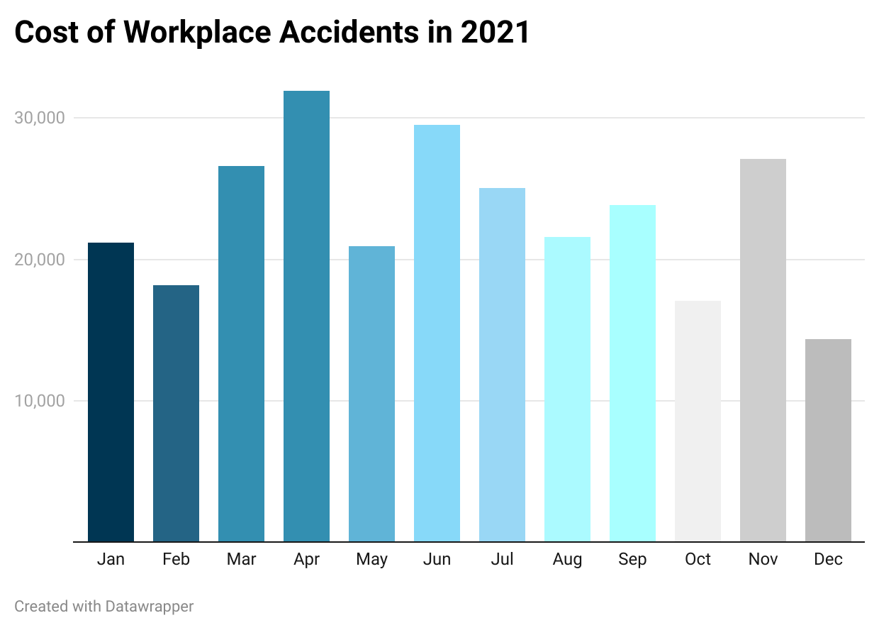

2. Food Data Story

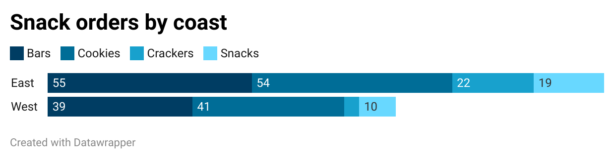

**Link =** <https://datawrapper.dwcdn.net/HBX8q/1/>

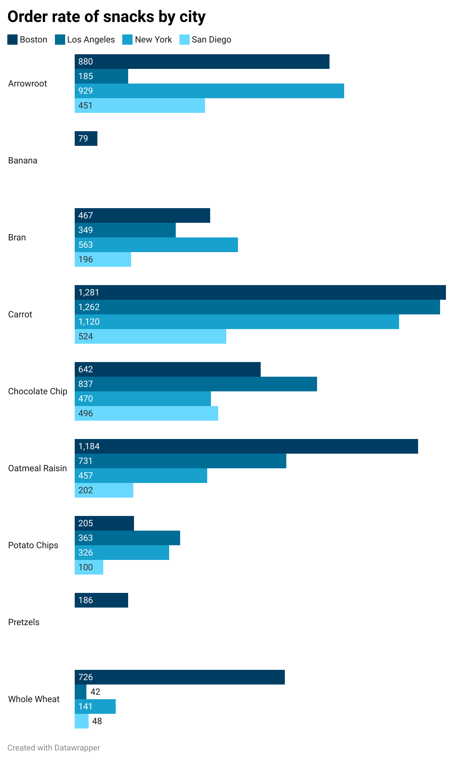

**Link =** <https://datawrapper.dwcdn.net/9XWuu/1/>

**Snack orders dominated by east coast cities**

The United States’ metropolitan coastal cities grossed a total of 244 snack orders between 2020 and 2021. Between the coastal cities, orders to the east coast cities surpassed snack orders to west coast cities by 56 orders, a difference of about a third.

Looking closer at the orders between the four cities — Boston, New York, Los Angeles, and San Diego — Boston topped orders in 5 out of 9 snack categories. Boston led orders of banana, carrot, oatmeal raisin cookies, pretzels, and whole wheat products. Close behind Boston was Los Angeles, whose orders in bran products, chocolate chip cookies, and carrots, were sufficiently high in comparison to the orders of New York and San Diego.

The most popular snack order in the east coast are bars, whereas the most popular snack order in the west coast are cookies. “Plain snacks,” consisting of potato chips and pretzels, were the lowest category purchased on both coasts. Trends towards healthy eating are certainly noticeable on both coasts, with the individual purchase of carrots topping orders in Boston and Los Angeles.

The city with the least orders in almost all categories is San Diego. San Diego is the market with the lowest orders in arrowroot, bran products, carrots, oatmeal raisin, potato chips, and wholewheat products. Its disproportionately low sales drag down order numbers of food on the west coast at large.

For this reason, the New York market cements itself as a stronghold on the east coast, with order numbers behind Boston, but fairly comparable to that of Los Angeles. New York leads the purchase of arrowroot and bran products amongst the four cities, and trails closely behind LA and Boston in the purchase of carrots, oatmeal raisin, and potato chips.